Chapter 3 p.49

Most targeted sectors globally

State-sponsored threat groups target broadly as part of their intelligence collection.

Critical infrastructure sectors (highlighted) comprised 41% of the NSNs sent in FY2023

Pie chart showing percentages of the most targeted sectors globally. It shows A. Education: 16%, B. Government: 12%, C. Think tanks and NGOs: 11%, D. IT: 11%, E. Communications: 6%, F. Finance: 5%, G. Transportation: 5%, H. Défense Industry: 4%, I. Energy: 3%, J. Manufacturing infrastructure: 2%, K. Other Critical Infrastructure: 5%, and L. Other: 20%. D, E, F, G, H, I, J, and K are highlighted.

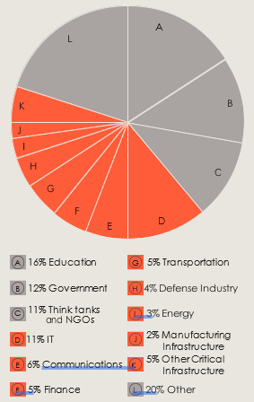

Source: Microsoft Threat Intelligence NSN data